ADIDAS TRIO LEAGUE SHIN GUARDS
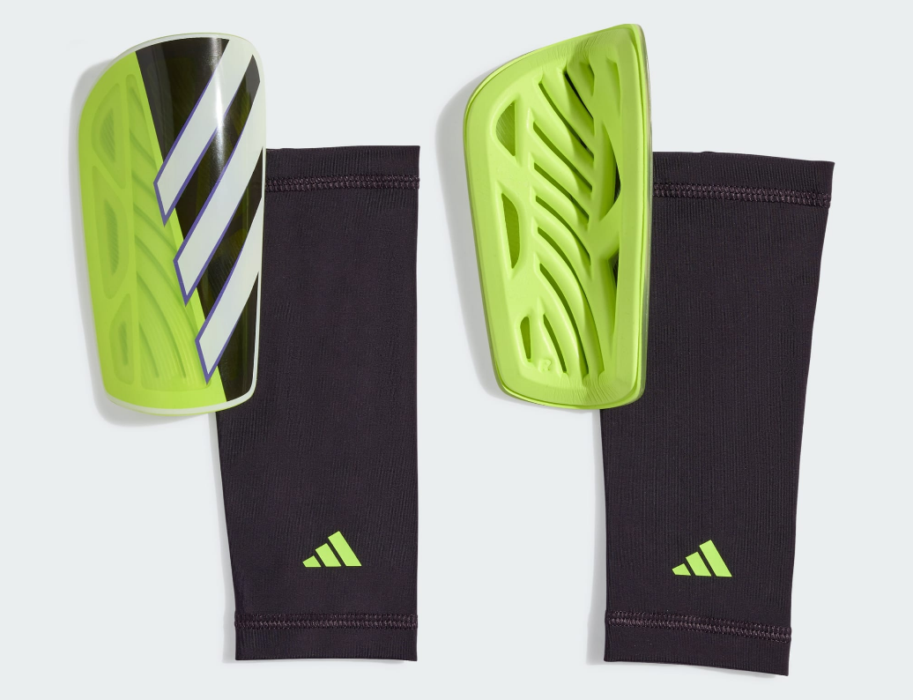
PRICE: Approximately Rs. 3,999

_{Introduction:}
The Adidas Trio League Shin Guards are designed to provide reliable protection and comfort for football players during training sessions and competitive matches. Built to absorb impact while maintaining a lightweight feel, these shin guards help reduce the risk of injury without restricting movement. Their ergonomic shape ensures a secure fit along the shin, allowing players to stay focused and confident on the field. Suitable for players of all levels, the Trio League Shin Guards combine functional protection with Adidas’ trusted quality and performance-driven design.
Product Overview:
The Adidas Trio League Shin Guards offer a balanced combination of protection and comfort. Featuring a hard outer shell with a cushioned inner lining, they help absorb impacts from tackles while remaining comfortable for extended wear.
About the Brand:

is a world-renowned sportswear brand known for innovation, quality, and timeless design. With a strong legacy in both sports and streetwear culture, Adidas continues to create footwear that blends performance, style, and durability for global audiences.

Key Features:
- Lightweight hard shell for impact protection
- Cushioned inner lining for added comfort
- Ergonomic shape for a secure fit
- Ventilated design to reduce heat buildup
- Designed for training and match play
- Durable rubber outsole for traction and stability

Design & Build Quality:
The Adidas Trio League Shin Guards feature a slim, contoured design that fits naturally along the shin. Reinforced construction and quality finishing ensure durability, while the smooth outer surface helps deflect impact during play, while the structured shape maintains long-term form and visual appeal.
Storage & Capacity:
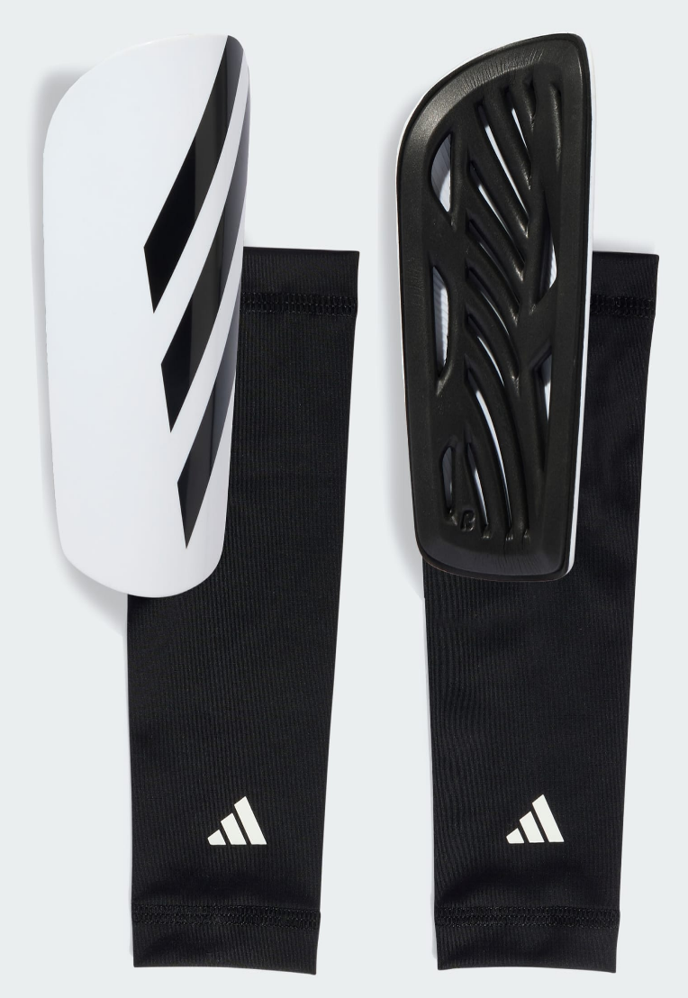
The compact and lightweight design allows the shin guards to be easily stored in sports bags or backpacks. They take up minimal space, making them convenient to carry for training sessions and matches.

Material & Durability:
Constructed from durable plastic with a soft inner padding, the Adidas Trio League Shin Guards are built to withstand regular football use. The materials maintain their shape and protective performance over time.
Ideal For:
- Football training sessions
- Competitive match play
- Amateur and semi-professional players
- Players seeking lightweight protection
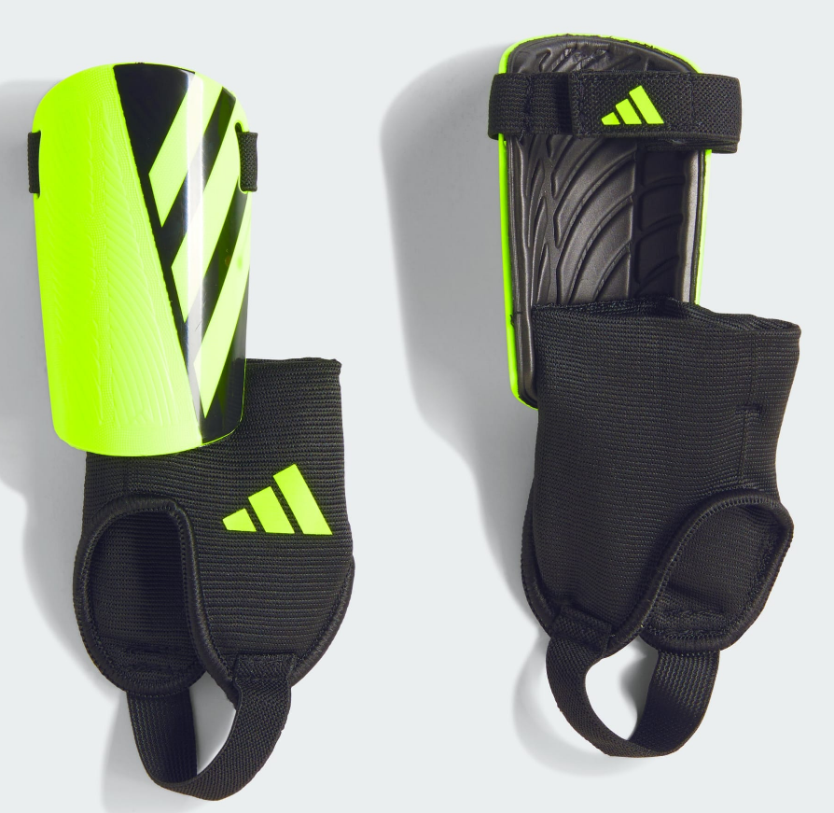

Care Instructions:
- Wipe clean with a damp cloth
- Do not machine wash
- Air dry after use
- Store in a dry place
Product Specifications:
- Brand: Adidas
- Model: Trio League
- Product Type: Football Shin Guards
- Outer Shell: Durable plastic
- Inner Lining: Cushioned padding
- Fit Type: Slip-in / Contoured
- Sizes Available: Small, Medium, Large
Product Summary:
The Adidas Trio League Shin Guards provide dependable protection, comfort, and a lightweight feel for football players. Designed for training and matches, they offer a secure fit and durable build, making them a reliable choice for players at any level.

